Instructions on how to execute and validate

**1.Prerequisites:**

* Before running the program, ensure that you have Java Development Kit (JDK) installed on your computer. You can download it from the official Oracle website: Java SE Downloads.
* Verify that Java is properly configured in your system's environment variables or PATH.

**2.Download or Clone the Repository:**

* Java program is provided as part of a repository <https://github.com/Abhishekcec/Technical-Exercises.git> , download or clone the repository to your local machine.

**3.Navigate to the Source Code Directory:**

* Using a terminal or command prompt, navigate to the directory containing the Java source code files.

**4.Compile the Java Program:**

* Compile them using the javac command. For example execute the below command to compile CionChange program:
* javac CoinChange.java
* 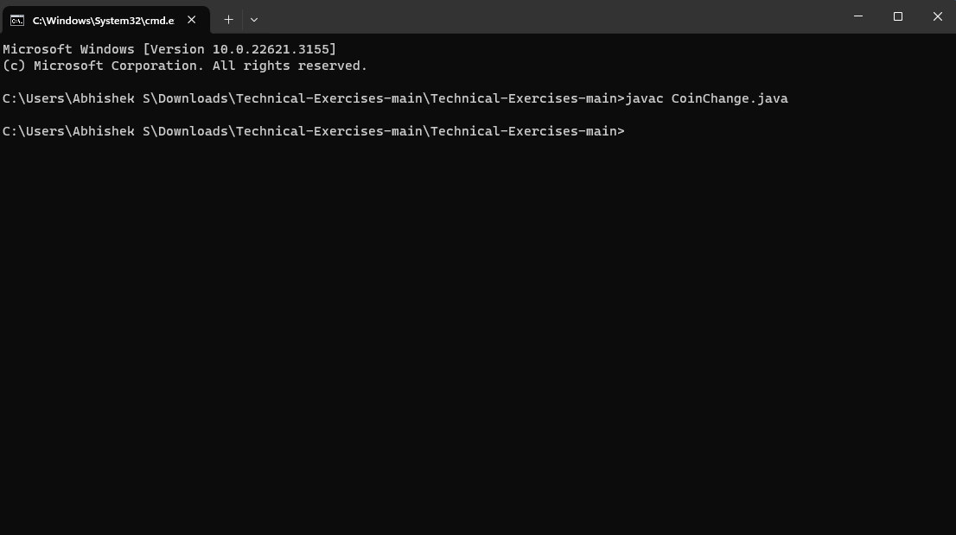

**5.Run the Java Program:**

* Once the source code is compiled, run the Java program using the java command followed by the name of the main class. For example:
* Run below command to execute CoinChange
* Java CoinChange.java
* 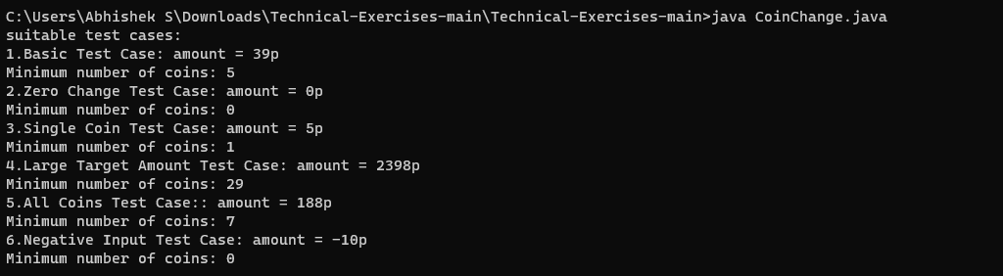

**6.View Output:**

* After running the program, observe the output displayed in the terminal or command prompt.